**Assignment Rafting Site – Planning Document**

1. 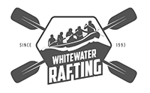**The image file you selected for the site logo.**
2. **Write out the four (4) color labels with the color codes you selected:**

* Primary-color: 7CB518
* Secondary-color: 5C8001
* Accent1-color: FB6107
* Accent2-color: FBB02D

1. **Write out the two (2) font labels and the names of the fonts you selected:**

* Heading-font: Poetsen One
* Text-font: DM Sans

1. **Provide the URL link to your color palette that you designed in coolors.co  
   Here is an example URL link:**

<https://coolors.co/fb6107-f3de2c-7cb518-5c8001-fbb02d>